How to Use the Template System
Contents
1. Get started 1
1.1. Synchronize SharePoint on local computer 1
1.2. Setup environment 1

Initial setup environment

Synchronize SharePoint on local computer
https://steria.sharepoint.com/sites/Qregulate/QDocuments/Forms/AllItems.aspx
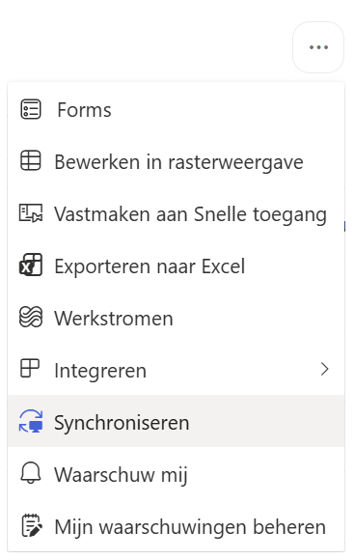

Setup environment
This template system supports a dev and prod environment. As a regular user (non-developer) follow this one-time instruction.
In Windows Explorer, open the folder "C:\Users\%your username%\Sopra Steria\Q-Regulate - Q-Documents\Master Template\SSG-MC". Double click on "junction.bat".
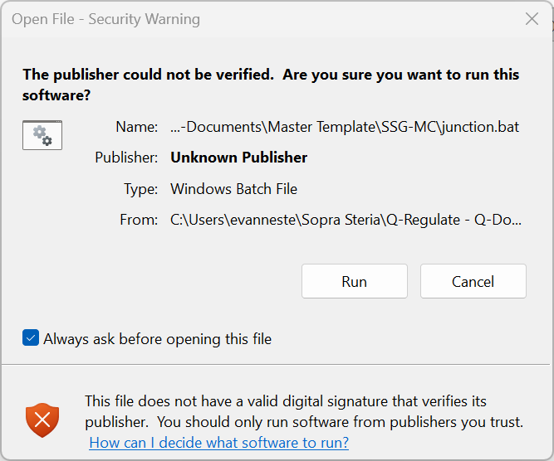
Figure 1: a security warning may pop up. Press "Run" to continue
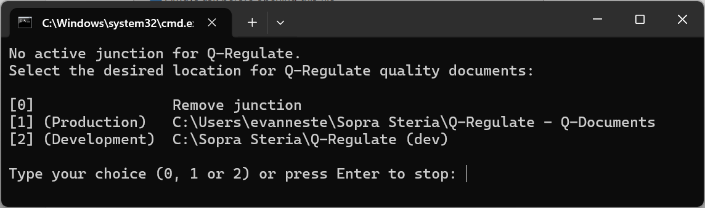
Figure 2: enter "1" as your choice
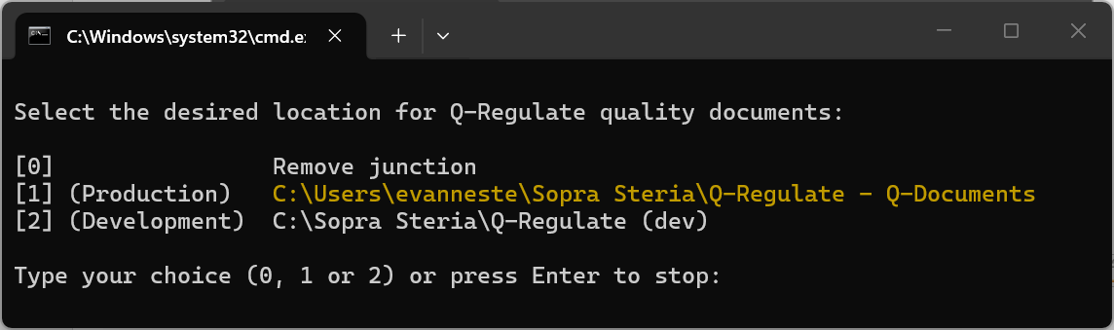
Figure 3: successful setting the working path will be shown in yellow. Contact template system owner when an error occurs.

Set-up Word

Set-up trust & Enable VBA Scripts
Go to Word > Options > Trust Center
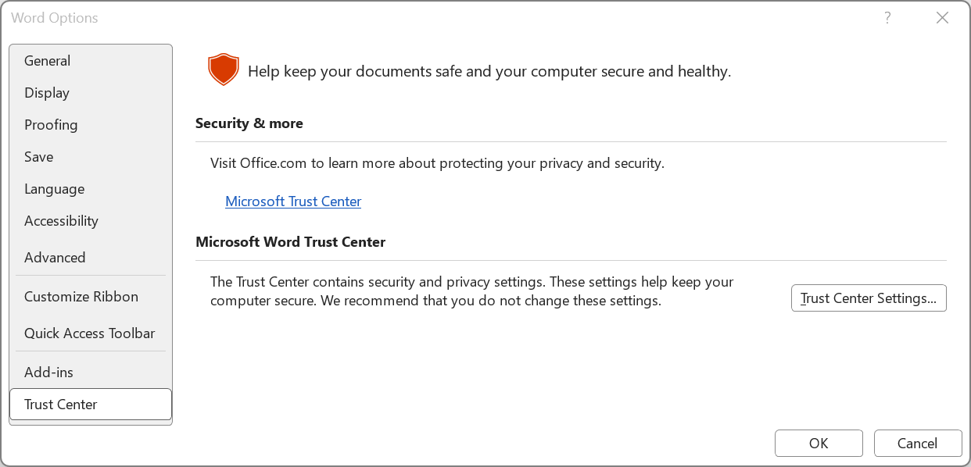
Click on Trust Centre Settings
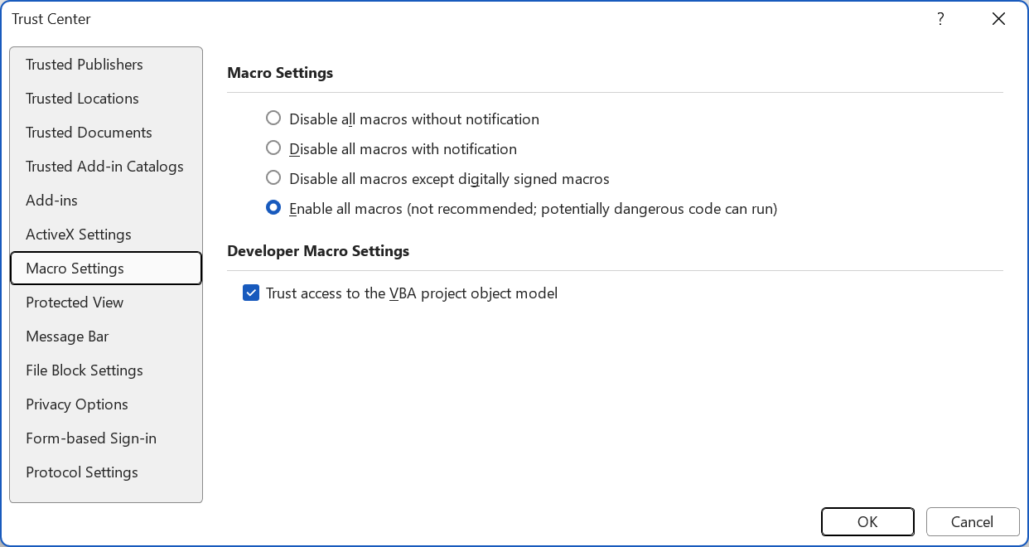
Mark "Enable all macros" and "Trust access to the VBA project object model".
Add Trusted Locations > Add new location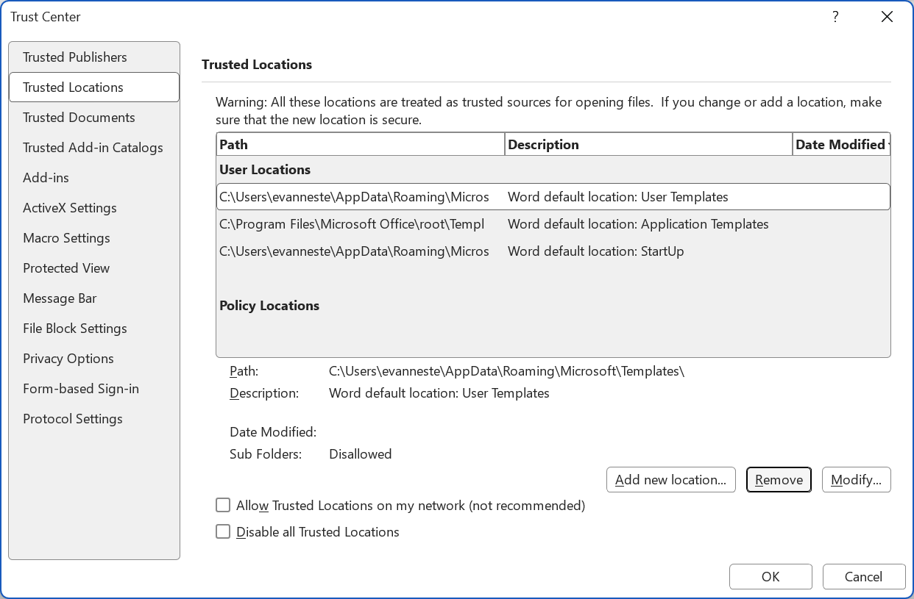
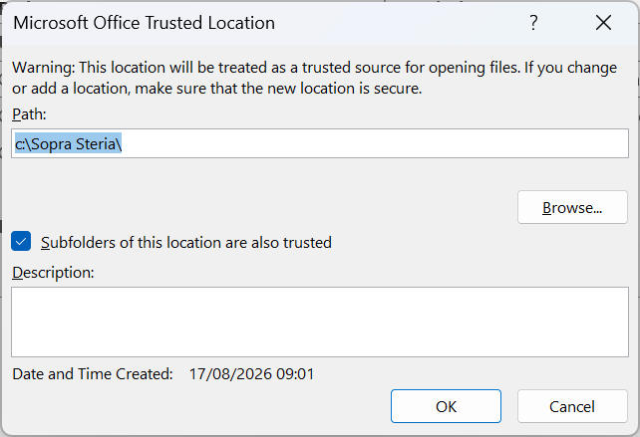
Click "ok" on all open screens.

Set Template location
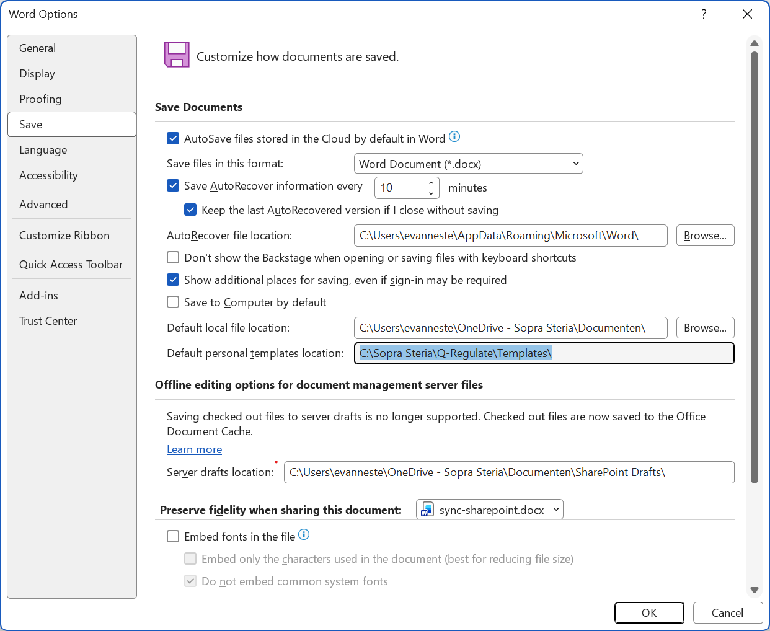

Get started

General remarks
Microsoft Word (referred to as Word in the remainder of the document), starts from a template to create a document. By default, "normal.dotx" is used, where the 't' in the file extension '.dotx' stands for template.
A document is initialised from this template, but it must be saved before it is on file. A file created from a template is saved as '.docx'.
In Word, a template typically contains a set of styles to help the author to layout the document.

Open Microsoft Word

